InterMountain Medical Clinic

City
1951 Bench Road, #B Pocatello

State
ID

Details
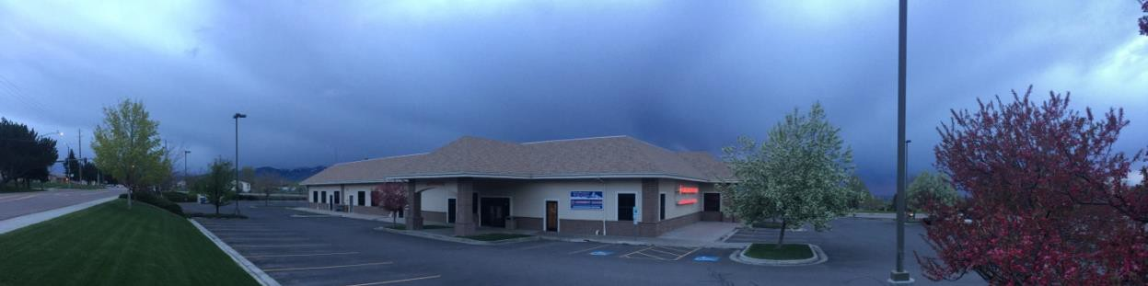
IMMC is a physician owned group practice of about 7 family physicians. Dr. James Marble is the clerkship coordinator and will coordinate your activities and schedule. You will spend time with Dr. Marble and several others in the practice (Drs. Andy Thayne, Brandon Mickelsen, Travis Nielsen, Jordan Hammon, and Scott Christensen). Most of our physicians are also involved in teaching at the Idaho State University Family Medicine Residency.

You will have opportunity to participate in the diversity of family medicine with multiple different physicians in the practice, including regularly scheduled clinic and an onsite urgent care staffed by the providers. You will also be able to participate in and choose from other learning experiences including hospital admissions, nursing home visits, home health and hospice visits in the patient’s home, a free clinic that serves uninsured and under-insured patients, a juvenile detention center, and a women’s prison. You may also have the chance to participate in obstetrical care in the clinic and OB call at the local hospital. We can usually accommodate other particular wishes and interests as well. Family medicine is diverse and versatile and we hope to provide you with that experience.

The Pocatello medical community has an active series of didactic sessions. Students usually spend one day a week at the Pocatello Family Medicine Residency, often in didactic teaching sessions or working with physicians in one of the outreach clinics offered (ie HIV, Women’s Prison, Juvenile Detention). There is one hospital, Portneuf Medical Center, a newer state-of-the- art facility where students can participate in admissions in the emergency room and rounding with the inpatient team.

As a part of this rotation you may be at Portneuf Medical Center. PMC uses the software platform myClinicalExchange. Lydia Carbis @ Idaho WWAMI will assist you in getting set up.

Satellites
None.

Community
Pocatello is a small, but growing city, population 60,000. The major economic base of the community is light manufacturing and industry, and agriculture.
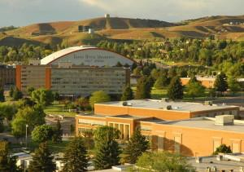

Pocatello is home to Idaho State University.

In an effort to support the community and promote wellness, InterMountain Medical hosts a Fun Run in June. Some of the physicians are also involved in helping (and running) in the Pocatello Marathon each year.
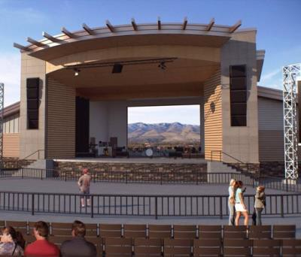

The Portneuf Wellness Complex an 80-acre, $10-million outdoor complex featuring seven multi- use fields, four sand volleyball courts, three basketball courts, miles of paved walkways, an amphitheater that seats up to 10,000 people, and a 6.35-acre urban fishing pond. The complex is

located across the street from InterMountain Medical Clinic. Pocatello is within a few hours of the Grand Tetons, Yellowstone Park, Sun Valley, Jackson Hole and Salt Lake City’s ski resorts. Any of these locations would be a great weekend getaway during your clerkship with us. Pebble Creek Ski Resort is a 15 minute drive. Fantastic hiking and mountain biking trails surround the valley.

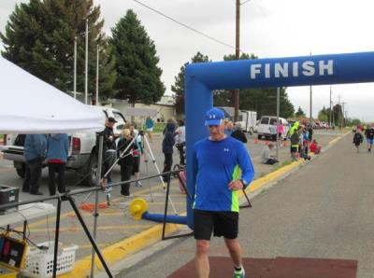

Check out Pocatello’s outdoor activities--hiking, fishing, mountain biking, backpacking, and skiing—all within 15 minutes of Pocatello.
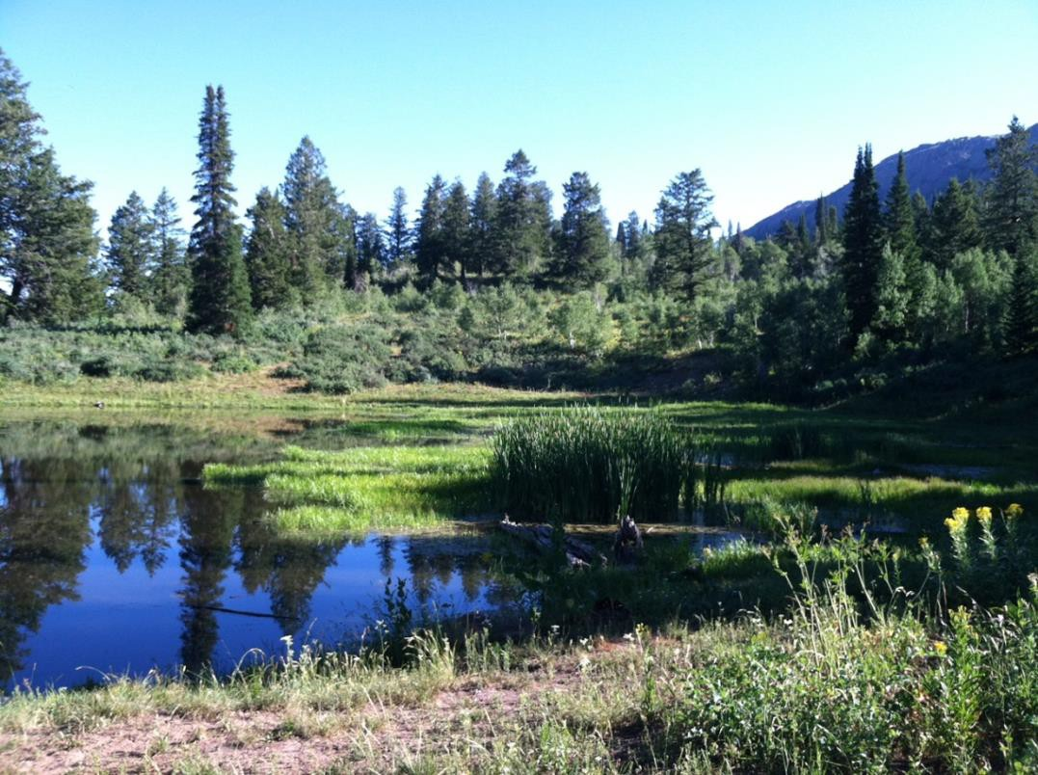

Duties

Students will be expected to participate actively in the care of the patients and should work to seek out continuity of care opportunities. Your independence in the clinic and other activities will evolve over the course of the rotation to expand your abilities. You will be expected to select two (or more if desired) evening urgent care shifts to participate in. Have a great time learning from the many different styles of practice amongst our providers. Family practitioners in the group have developed special practice emphases including diabetes, female medicine, obstetrics, pediatrics, osteoporosis, geriatrics, hospice, and faculty development.

Housing
You can stay in our newer, two bedroom, two bathroom townhouse that includes a garage, patio and all the amenities. Washer and dryer, TV and high speed wireless internet, dishwasher, full size stove, refrigerator and microwave. The house is furnished; new living room furniture, bedding, cookware, dishes, towels, sheets, and ironing board. Arrangements for spouse or family can be made with the site coordinator and other student sharing the rotation (if applicable). The apartment is located within a half mile of the clinic, four miles of the hospital and close to shopping and restaurants. No pets please. Car required.

Other
Some facts about the weather in Pocatello:

- On average, the warmest month is July.
- The highest recorded temperature was 104°F in 2000.
- On average, the coolest month is December.
- The lowest recorded temperature was -33°F in 1985.
- The maximum average precipitation occurs in May.

Contact

Lydia Carbis: carbisl@uw.edu
Shelly Stranski: stranskis@famprac.com
Tanya Smith: tanya.smith@portmed.org
Please email Shelly to coordinate your clerkship.

