Butte, Montana
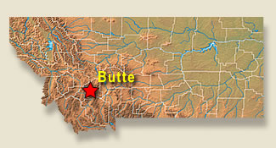 | 445 Centennial Ave  Butte, MT 59701  Phone: 406-723-4075

Primary Preceptor: Serena Brewer, D.O.
Email: sbrewer@swmtchc.org
Serena Brewer, D.O., Family Medicine:
Undergrad: Willamette University, Salem OR, majored in Sociology. Went to Kirksville College of Osteopathic Medicine, Kirksville, MO and completed her residency at Santa Rosa Family Medicine Residency. She specializes in women’s and adolescent health. Loves to cook, rebuild old trucks, ski, and fly fish.
Family Medicine Physicians:
Shawna Yates, D.O., Wendy Grace, MD, Care Downey MD
Students should contact the coordinators 6 – 8 weeks or more from the start of their rotation for the appropriate forms and information.
Clinic Coordinator: Breanna Hall bhall@swmtchc.org
Hospital Coordinator: Emily Stenson, Emily.Stenson@sclhs.net
HR Coordinator: Michele Shea, mshea@swmtchc.org

Students are required to have annual TB testing at this site. Please follow the directions you are given from the site. *Note* this is different than the TB requirement for UW-SOM.

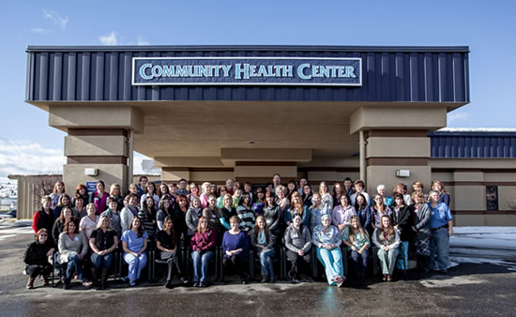
Clinic:
Founded in 1986, the Southwest Montana Community Health Center (SWMTCHC) is a Federally Qualified Health Center serving 13,000+ patients. A third of our patients live at our below the federal poverty line. Our patient mix is 10% uninsured, 30% Medicaid, 30% Medicare, 30% private insurance. Our catchment area includes the City and County of Butte-Silverbow and surrounding counties of southwest Montana.
We believe that every person, regardless of race, age, sex or personal income, has the right to receive quality health care in a supportive atmosphere. Our Mission is to inspire hope and empower wellness by providing access to comprehensive healthcare.
We provide care through 3 physical locations, 2 retail pharmacies, homeless shelter outreach and 2 school based health centers. Our services include comprehensive medical (adult and pediatric) and dental care, clinical and retail pharmacy, integrated behavioral health and MOUD therapy. Our providers specialize in family practice, pediatrics, women’s health, prenatal care and geriatrics.
Currently the clinic has 6 fulltime physicians and 13 midlevel providers including nurse practitioners and PAs. The Butte clinic is an active teaching site for students across the spectrum of healthcare including medical students and residents, pharmacy students, nursing and MA students and behavioral health students. You will regularly interact with and work alongside many students during the family medicine clerkship

Family medicine clerkship students get to participate in outpatient procedures including biopsies, suturing, colposcopy, IUD insertion and removal, joint injections and joint aspirations. Additionally, we utilize your clerkship time to teach time management, charting and organizational skills. Clerkship students have their own panel of patients to manage during their time with us. Your days are primarily divided between two main preceptors with opportunities to work with other providers depending on your interests. We meet for a weekly teaching breakfast at which you will be asked to teach your classmates and preceptors about a family medicine topic. Our outpatient clinic is busy, but we think you will enjoy it as much as we do!
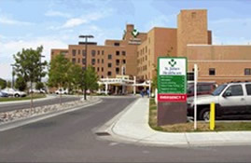
Medical:
The SWMTCHC is affiliated with SCL Health -St. James – a part of intermountain Health. St. James offers the people of Southwest Montana specialized services in Cardiology, Oncology, Orthopedics and Women's & Children's services. It is a 100-bed facility staffed by more than 500 employees, all dedicated to the integration of tradition and technology. For more than 125 years, St. James Healthcare has played an important role in the history of Butte. Founded in 1881 by the Sisters of Charity of Leavenworth (Kansas), St. James has been known for generations for its mission of compassionate care and service to the poor.
Getting to Butte:
Butte, MT, lies in the Southwest portion of Montana. It’s about a 2 hour drive to the Idaho border to the south down Interstate 15. Likewise, Missoula is about a 2 hour drive to the west along Interstate 90. Helena, the state capitol, is about 80 miles to the north of Butte along Interstate 15.
About Butte:
For more than a century, copper was king in Butte, Montana and this city became one of the world's most important sources for the strategic metal. In the process, the wealth generated by mining and refining earned Butte, Montana the name "The Richest Hill on Earth." For many reasons unrelated to mining, Butte, Montana remains the Richest Hill on Earth.
The headframes scattered across the Hill are symbols of this proud mining heritage. Called gallows frames by miners, they lowered men to work in the stopes below and on the return trip to the surface they brought up the rock in the box. They are silent sentinels of the era of underground mining that punctuate the Butte landscape like steel exclamation points.
Butte, Montana is rich in history, art and culture in the midst of one of the most beautiful areas of Southwest Montana. Rimmed by the peaks of mountain ranges, Butte provides nearby access to trout fishing, world-class golf courses, hiking, hunting, skiing, soaking (in commercial hot springs), snowmobiling, and many other outdoor recreational opportunities.

Housing & Car:
A car is a must for any clinical rotation in Butte as students work in multiple offices and public transportation, while free, does not routinely travel between offices.
Housing is either a small cottage located next to the hospital or a furnished apartment several blocks east of the hospital. Students will generally have the housing experience to themselves – very rarely we ask you to share with TRUST students of er long weekends or breaks between classes. No pets please.
Climate:
Butte, MT climate is mild during summer when temperatures tend to be in the 60s and extremely cold during winter when temperatures tend to be in the 10'.
The warmest month of the year is July with an average maximum temperature of 79.80 degrees Fahrenheit, while the coldest month of the year is January with an average minimum temperature of 5.40 degrees Fahrenheit.
Temperature variations between night and day tend to be relatively big during summer with a difference that can reach 35 degrees Fahrenheit, and moderate during winter with an average difference of 25 degrees Fahrenheit.
The annual average precipitation at Butte is 12.78 Inches. Rainfall in is fairly evenly distributed throughout the year. The wettest month of the year is June with an average rainfall of 2.07 Inches.
Copper King Mansion
Extracurricular Activities:
Golf
Butte Country Club • Highland View Golf Course
Guides and Outfitters
Big Sky Angling Services • Montana Professional Hunters • Tom's Fishing & Bird Hunting Guide Service • Wild Skies Outfitting & Mountain Company
National Forests
Beaverhead-Deerlodge National Forest • Helena National Forest
Tours
Copper King Mansion • Ghost Walks - The World Museum of Mining • Old Butte Historical Adventures • Our Lady of the Rockies
Popular Community Events:
The Chinese New Year's Parade • St. Urho's Day • St. Patrick's Day • Butte Freedom Festival • 1st Annual Montana Folk Festival • Evel Knievel Days • Montana Irish Festival • Farmers' Market • Annual Christmas Stroll • Annual Ice Sculpting Contest

