What are the Six Building Blocks?
The Six Building Blocks, described below, are six key work areas you can redesign to improve your clinic’s management of patients who are on long-term opioid therapy. Learn more at www.improvingopioidcare.org.
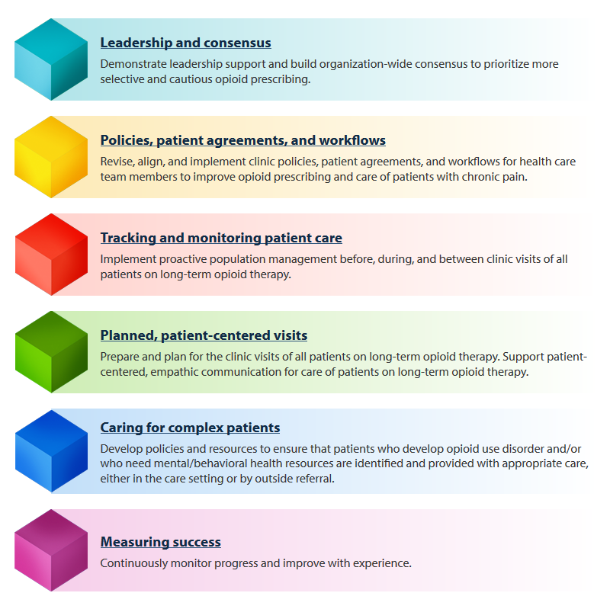

What is the Six Building Blocks Program?
The Six Building Blocks Program supports primary care teams in implementing effective, guideline-driven care for their chronic pain and long-term opioid therapy patients. The Six Building Blocks Program is a tailored approach that offers a variety of kinds of support to match an organization’s needs and time. The following tables provide an overview of the types of services we can offer.

Comprehensive QI facilitated program
The below table outlines an evidence-based program for implementing opioid management improvements supported by a trained practice facilitator.
Content | Time and commitment
Guidance in implementing comprehensive opioid management system-based improvements.  This is the full Six Building Blocks Program, which includes:  - Guided assessment  - In-person kickoff event  - Action plan development support  - Connection to resources and education  - Facilitated shared learning calls  - Ad-hoc assistance | 9-15 months  Opioid improvement team (clinical champion, QI project manager, data manager, others as desired) will:  - Provide vocal, engaged leadership throughout the Six Building Blocks program.  - Create an opioid improvement team that typically includes a clinical champion, a program manager, a tracking and monitoring lead, and others from the clinic as desired.  - Regularly update action plans to achieve milestones.  - Provide protected time for a designated staff member to develop and begin implementing an approach to tracking and monitoring patients on long-term opioid therapy, including:  - updating patient data, as necessary;  - generating reports for patient care planning;  - generating regular performance reports.  - Provide protected time for the opioid improvement team to meet internally at least once each month to review and assess progress and data, and make plans to continue the improvement work.  - Provide time to participate in calls with the practice facilitator.  - Provide time for the clinical champion and other clinicians and staff to participate in clinical education.

Other types of support available
If your organization does not have the capacity or interest in the full program, we can also offer individual components of the program, as described below.
Service | Six Building Blocks facilitator commitment | Clinic commitment | Time
Six Building Blocks consultation | Six Building Blocks facilitator will:  - Provide focused, facilitated guidance in doing an in-depth assessment  - Identify areas for chronic pain and opioid management improvement during a “give back” meeting | Clinical champion and QI project manager will:  - Work with the Practice Facilitator to complete a clinic self-assessment  - Gather existing resources | 1-3 months
Technical assistance | Six Building Blocks facilitator will:  - Provide ad-hoc support and technical assistance in opioid management areas, as needed. For example:  - Policy development/revision to align with WA 1427  - Workflow development/revision to support policy implementation  - Creating a tracking and monitoring system | Clinical champion and QI project manager will:  - Work with the Practice Facilitator to assess needs  - Implement action plans | Ad-hoc

How do I choose between these support options?
We would be happy to talk this through with you to determine what makes the most sense for your organization. Reach out to [NAME & CONTACT INFO] and we can set up a time to discuss this more.

